**Experiment 24**

**AIM :**

To design DFA trasition diagram starting with a’s or b’s in automata.

**Design and output:**

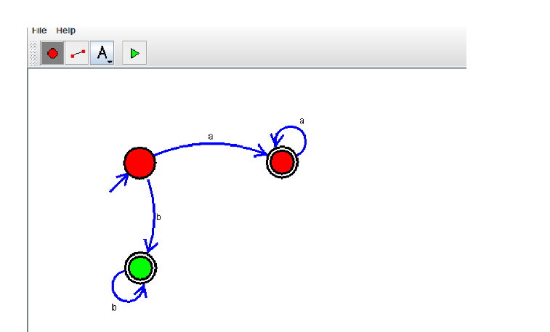

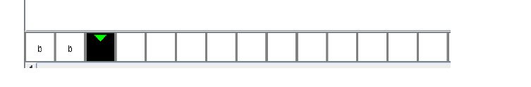

**Result:** Thus designing DFA which starts with a’s or b’s is done and verified by giving sample inputs.